# Ex. No.: 5 Date: 15/11/2021

# Finding Resonance Frequency

## Aim:

To find the resonance frequency in an RLC circuit, a circuit involving a resistance, capacitor, and inductor.

## Apparatus:

ORCAD / Capture CIS: Analog Library – R, L, C

Source Library – Vac

Ground (GND) – 0 (zero)

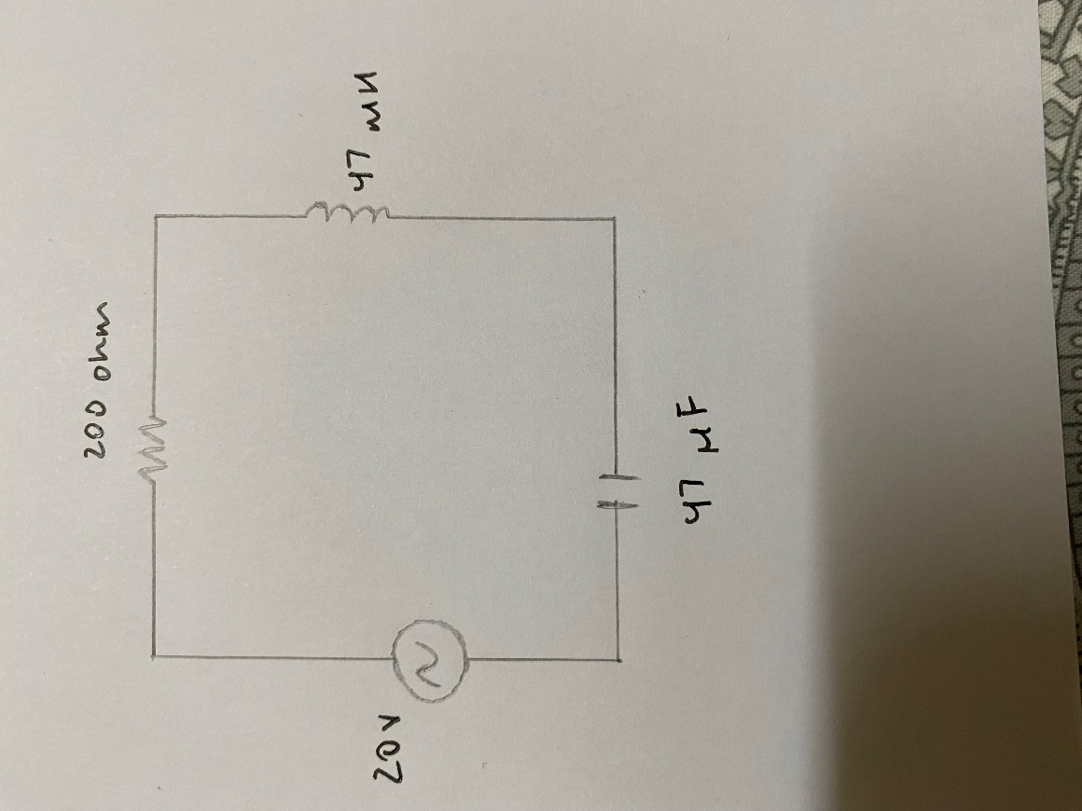Simulation Settings: Analysis Type – AC Sweep

Circuit Diagram for Maximum Power Transfer Theorem:

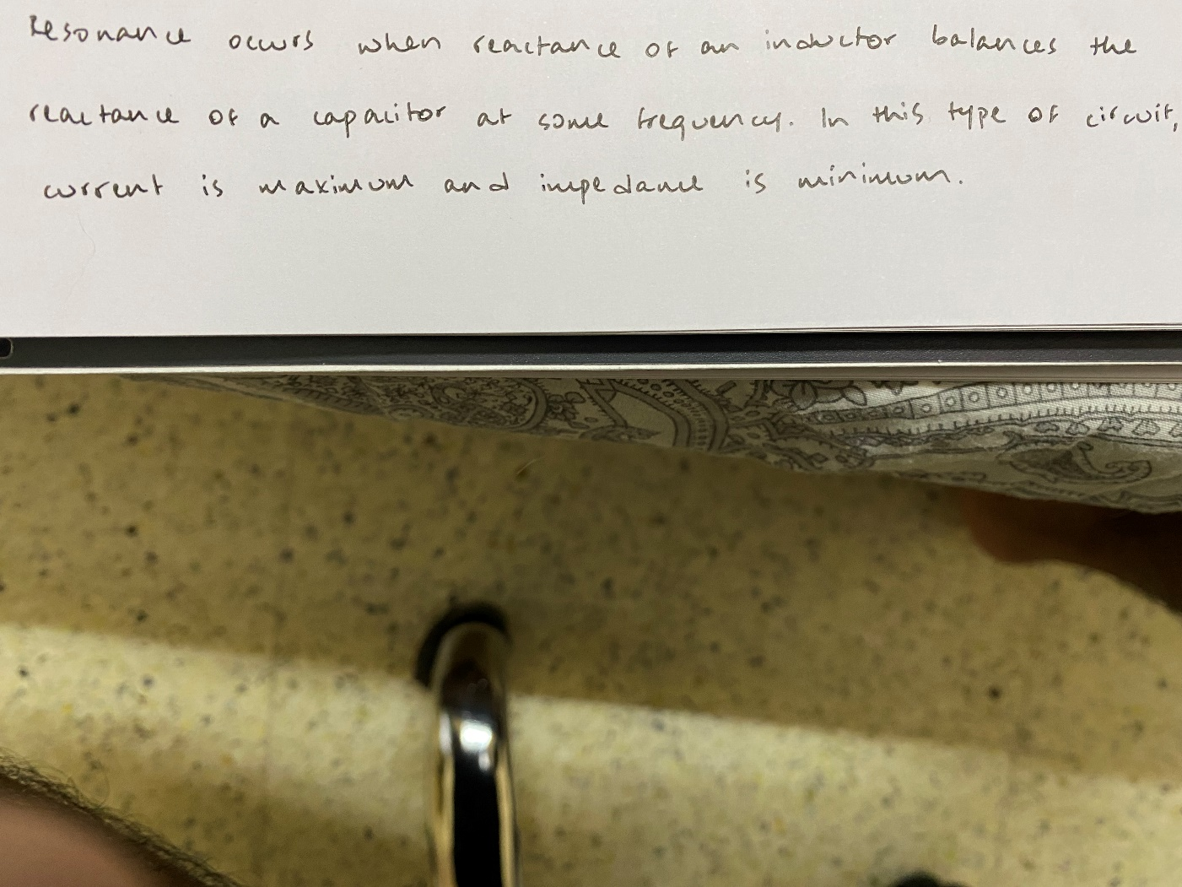

Statement:

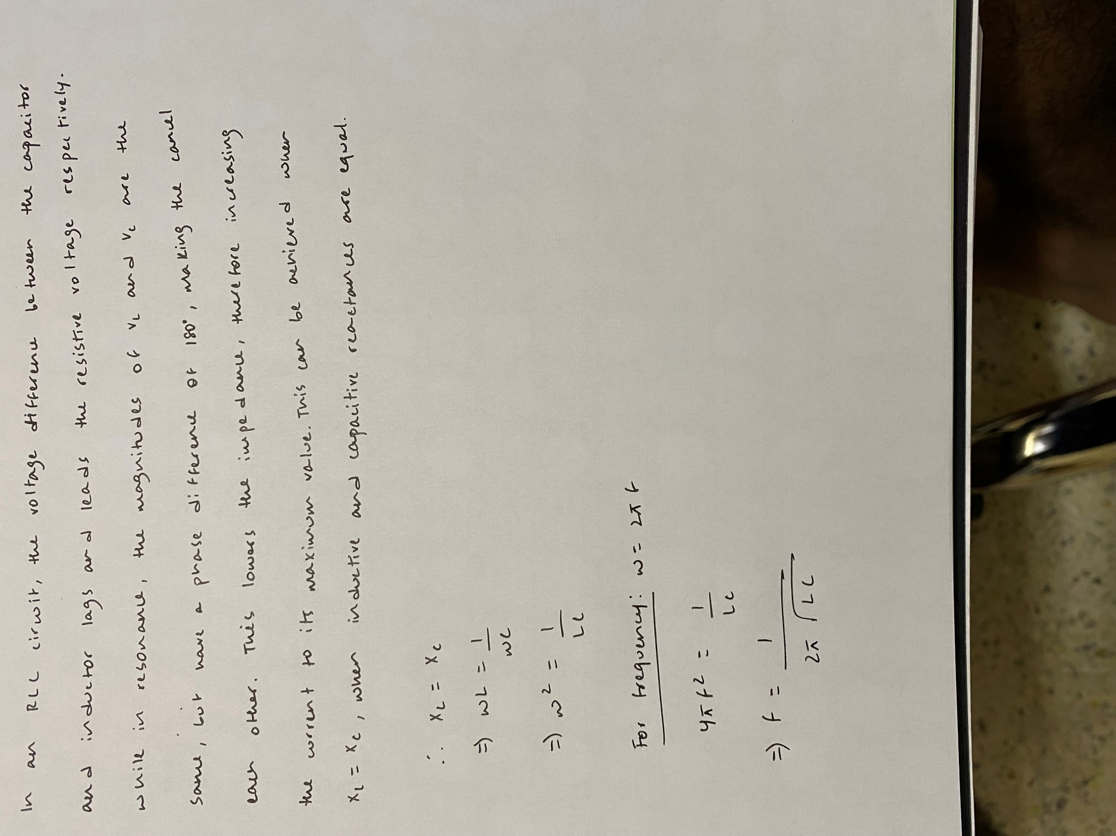Theory and Formula:

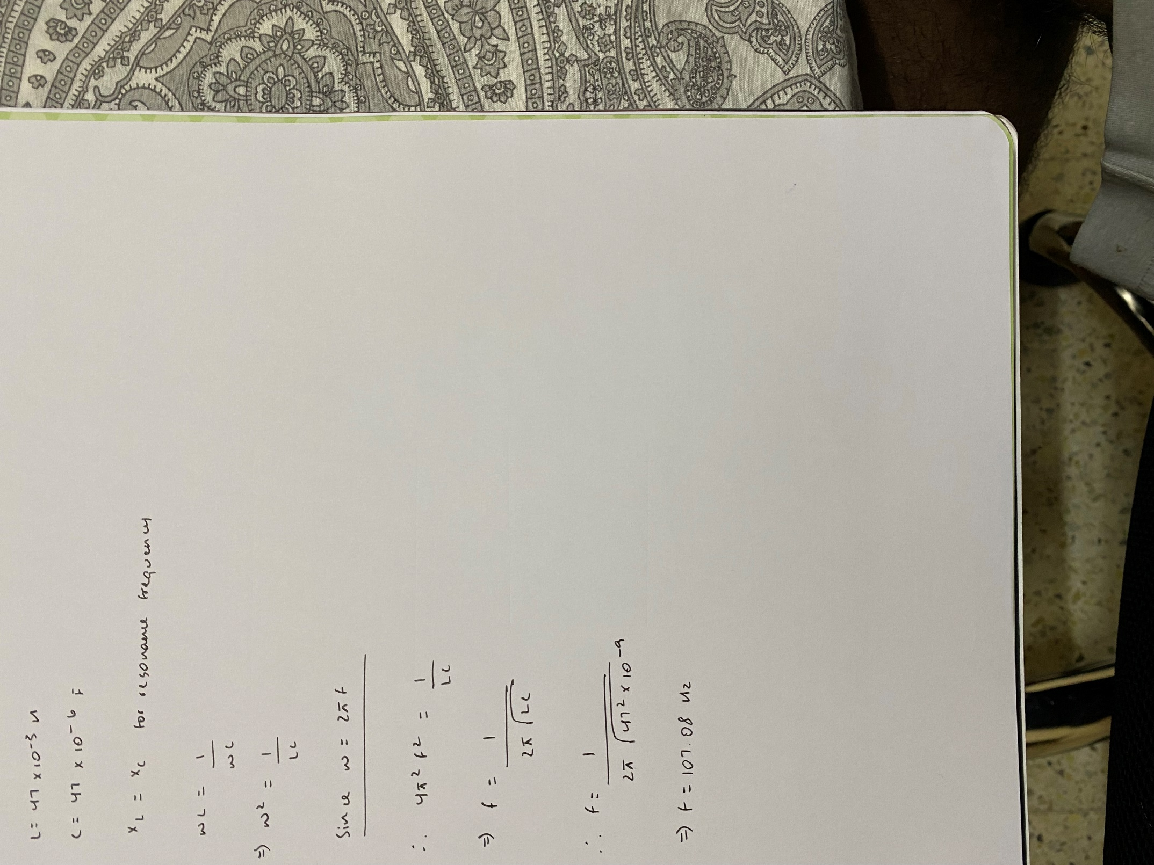Manual Calculations:

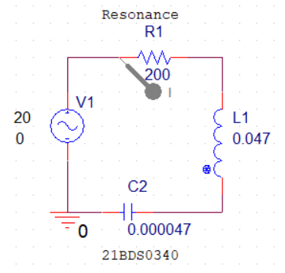Simulation Circuit:

Procedure:

Result:

### Current vs Frequency Graph:

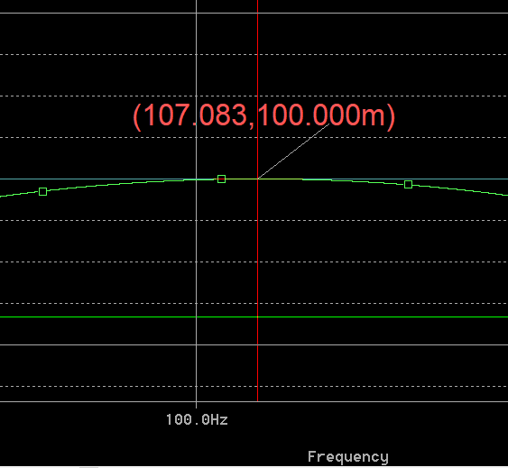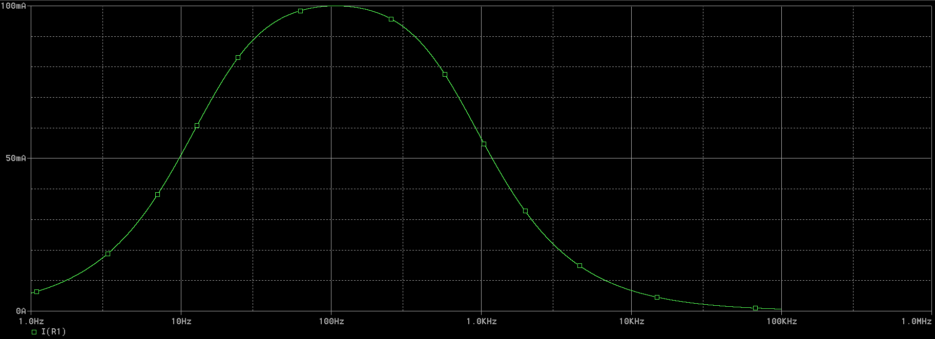

### Resonance Frequency and Corresponding Current Value Enlarged:

### Resonance Frequency

|  |  |  |
| --- | --- | --- |
| Notation | Manual Calculations | Simulated Result |
| f | 107.08 | 107.083 |
| Pmax | 0.1 | 0.1 |

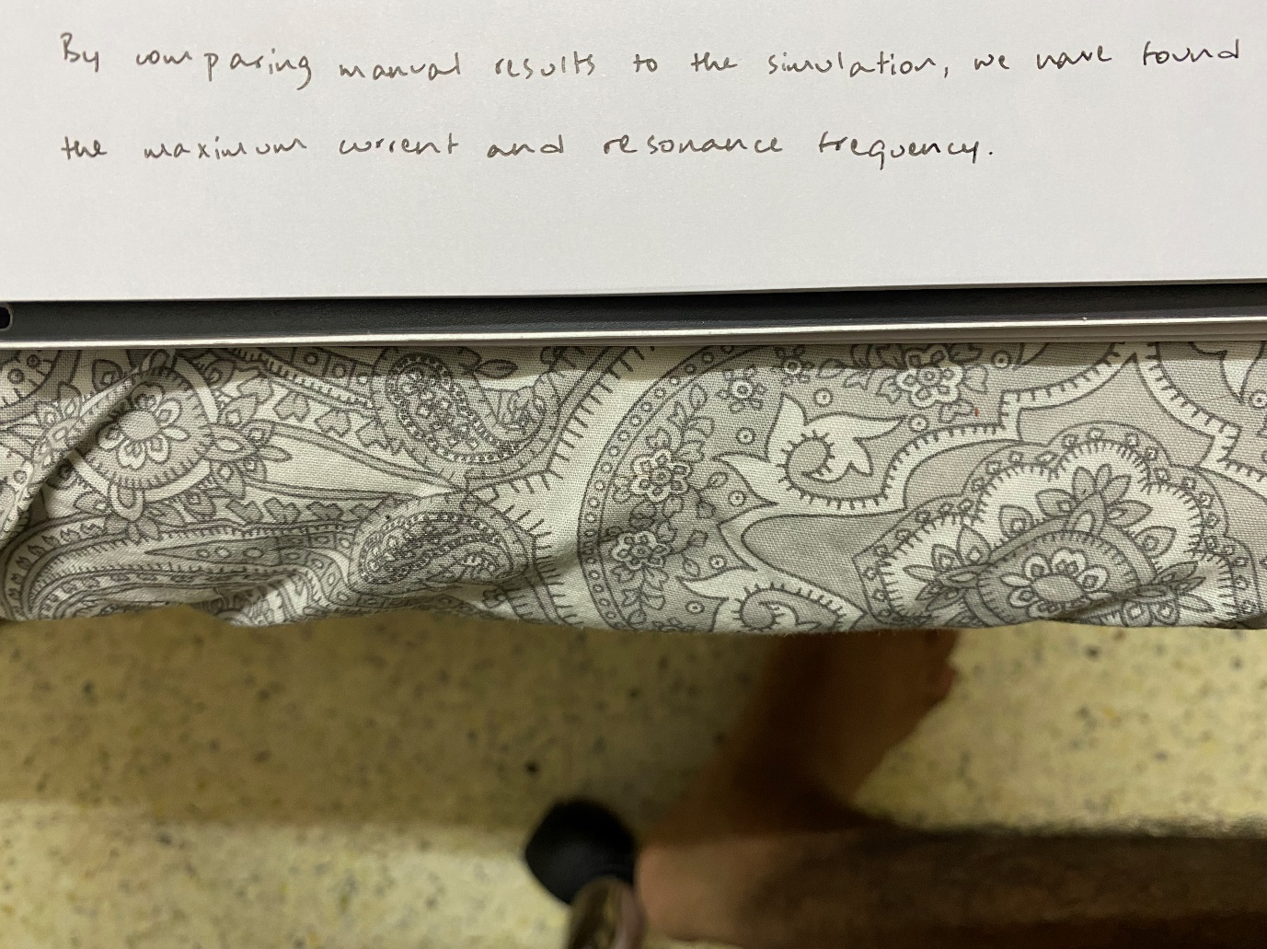Inference:

**Reg. No: 21BDS0340 Name: Abhinav Dinesh Srivatsa Date: 15/11/2021**